Assignment 2

*Note: When you turn in an assignment to be graded in this class, you are making the claim that you neither gave nor received assistance on the work you turned in (except, of course, assistance from the instructor or teaching assistants).*

Write the following Python program in a Python class named Assignment2.py and upload the completed program to Gradescope. The goal of this program is to take a collection of rectangles and display them on a canvas so that none of the rectangles overlap with each other. To accomplish this task, your program will define several methods and classes. Note: parameters and return values **must** be in the order they are listed in the assignment manual

A class CustomCanvas

The CustomCanvas object will have a single instance variable of type Canvas, a built-in object defined in the python package tkinter. Documentation for the Canvas class can be found here: <https://anzeljg.github.io/rin2/book2/2405/docs/tkinter/canvas.html>. Note: you will need to import the Canvas class from the tkinter package.

CustomCanvas will have a constructor which takes two explicit arguments, height and width, which are expected to be of type int. The constructor will create a new Canvas object with the height and width provided.

A class Rectangle

Rectangle will have a constructor which takes four explicit parameters, height, width, x, and y. All four arguments are expected to be of type int. x and y represent the origin point of the given rectangle. The origin point will be the upper left corner. Parameters x and y should have [default values](https://docs.python.org/3/tutorial/controlflow.html#default-argument-values) of zero. The values received as parameters should be stored in instance variables of the same name.

A function pack

The pack function will have two parameters, allRect and canvasSize. allRect will be a list of Rectangle objects and canvasSize a tuple containing a canvas’ height and width (in that order). pack will take the given list of rectangles and determine a location for each rectangle so that each rectangle does not overlap another and each rectangle exists within the given canvas size. pack will then return a list of placed Rectangle objects. Each given rectangle must be included in the returned list.

Please note: This is not a trivial problem to solve! The pack function’s behavior is part of a class of problems known as [bin packing](https://en.wikipedia.org/wiki/Bin_packing_problem). Creating a working pack function from scratch is a very large undertaking. Consequently, I *highly* recommend using an external library to do the actual bin packing. The bulk of the work should be integrating whichever external library you find into the pack function. The pack function should behave exactly as described in the previous paragraph but the complex bin packing is done via the external library.

Also note: Each given rectangle is referring to the logical concept of the rectangle shape not the specific Rectangle object. Two Rectangle objects are logically equivalent if they have the same height and width. When generating the list of Rectangles to return, you can modify the given Rectangle objects or create new, but logically equivalent, Rectangle objects

A function main

The main function will read in a filepath as a [command line argument](https://www.tutorialspoint.com/python/python_command_line_arguments.htm). You may assume the filepath is always the second command line argument given (the first is the name of the class being executed) The given filepath will point to a txt file containing a canvas size and rectangles. The first line of the given text file will contain two int’s separated by a comma. These int’s represent a canvas’ height and width (in that order) All following lines represent the height and width of an individual rectangle.

main should parse the data in the file and use the information to create a new CustomCanvas object and a new list of Rectangles. Once generated, the list of Rectangles and the size of the canvas should be passed to the pack function. Main should then print each Rectangle contained in the retuned list to the instantiated CustomCanvas object. Each printed Rectangle should have a black border and a colored (not black or white) fill. Finally, main will [display the canvas, with packed rectangles, to the screen](https://www.pythontutorial.net/tkinter/tkinter-canvas/).

Main should be called whenever Assignment2.py is run as a stand-alone file but not when Assignment2.py is loaded as a library.

A few notes about the assignment:

* Project should be developed using Python 3. No Python 2 code will be accepted
* You can create other classes or other methods in the described classes as you see fit
* Four data files are included with this lab. You must successfully pack and draw all rectangles specified in 25PrecentFill.txt, 50PrecentFill.txt, and 75PrecentFill.txt.
  + Successfully packing and drawing the rectangles specified in 95PrecentFill.txt will result in +5 bonus points.
* You may use external libraries for this project **IF** the external libraries are installable via [pip](https://pypi.org/project/pip/)
  + If Gradescope does not recognize the external library you are using, please DM / email me ASAP and I will update Gradescope
* Linux shells on Windows machines may not be able to generate graphics

Sample input and output:

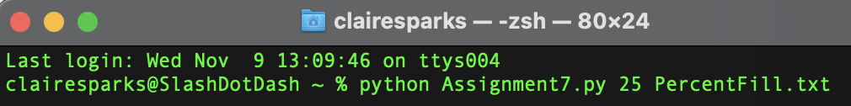

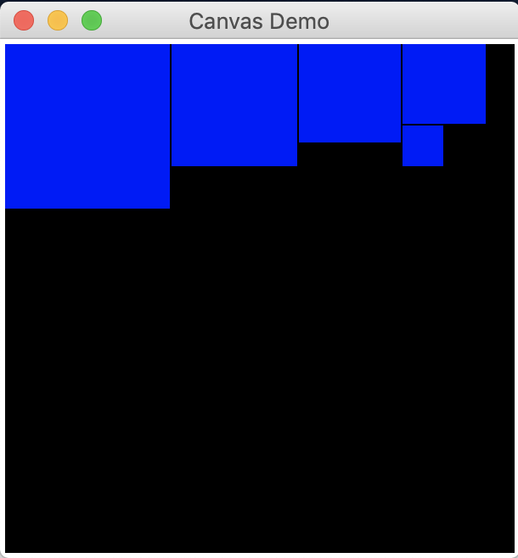

Grading Rubric:

|  |  |
| --- | --- |
| Category | Points |
| Methods and Classes properly defined | 20 |
| Functions as both a package and a standalone file | 10 |
| Proper use of canvas to draw rectangles | 30 |
| Pack function produces correct output | 30 |
| Code is commented | 10 |
| Total | 100 |